HandsMen Threads: Elevating the Art of Sophistication in Men's Fashion

Project Overview
HandsMen Threads, a premium men's fashion brand, is implementing Salesforce CRM to transform its business operations. This initiative will streamline order management, optimize inventory control, automate marketing campaigns, and deliver exceptional customer service through an integrated digital platform.

Objectives
HandsMen Threads is launching a comprehensive Salesforce project to revolutionize data management and strengthen customer relationships. The implementation centers on building a robust, scalable data architecture that ensures seamless information flow across all organizational touchpoints.
Central to this project is maintaining data integrity at the user interface level, which safeguards accuracy and consistency—essential foundations for strategic decision-making and reliable business operations. The platform will integrate four key automated processes to enhance operational efficiency and customer satisfaction:
Automated Order Confirmations: Customers receive immediate email notifications upon order confirmation, creating transparency and building trust throughout the purchase journey.
Dynamic Loyalty Program: The system automatically updates customer loyalty tiers based on purchase history, enabling personalized rewards that drive engagement and encourage repeat business.
Proactive Stock Alerts: When inventory drops below five units, the warehouse team receives automated notifications, ensuring timely replenishment and preventing lost sales due to stockouts.
Scheduled Bulk Order Processing: Each night at midnight, the system processes bulk orders in a single batch operation, updating financial records and adjusting inventory levels to ensure accurate stock availability for the next business day.

Phase 1:
Requirement Analysis & Planning
Use Case :
Developing a premium fashion platform to streamline men’s bespoke tailoring and enhance customer experience through personalized styling and seamless order management.

Instructions:
- Salesforce CRM Implementation
- Process Automation & Workflows
- Apex & Trigger Implementations
- Batch Jobs & Scheduled Processes
- Data Security & Access Control

Phase 2:
Salesforce Development - Backend & Configurations
Setup environment & DevOps workflow:
- Creating Developer Account
- Creating a developer org in salesforce.
- Account Activation

App, Object and field creation:
- The following are the Custom objects which we created
  - HandsMen Customer
  - HandsMen Order
  - HandsMen Product
  - Inventory
  - Marketing Campaign

- Data Management Tabs Creation for each object
- Creation in Salesforce Platform
- The following are the fields that we created in objects:
    - HandsMen Customer:
    - First Name
    - Last Name
    - Email (Email),
    - Phone (Phone),
    - Loyalty Status (Picklist: Bronze, Gold, Silver)
    - Total Purchases (Number)

    - HandsMen Product:
    - Name (Record Name),
    - SKU ( Text ),
    - Price (Currency),
    - Stock_Quantity__c (Number)

    - HandsMen Order:
    - Order_Number (Record Name),
    - Status (Picklist: Pending, Confirmed, Rejection),
    - Quantity__c (Number),
    - Total_Amount__c(Number)

    - Inventory:
    - Auto Number (Record Name),
    - Warehouse (Text),
    - Stock_Quantity__c (Number)

    - Marketing Campaigns:
    - Campaign_Name (Record Name),
    - Start_Date (Date),
    - End_Date (Date)

- Formula Fields:
- FullName (HandsMen Customer)
Formula : FirstName & " " & LastName
- Stock Status (Inventory)
Formula : IF(Stock_Quantity__c > 10, "Available", "Low Stock")

- Lookup Relations:
  - Marketing Campaign and HandsMen Customer
  - HandsMen Product and HandsMen Order
  - HandsMen Order and HandsMen Customer

- Master-Detail Relationship:
  - Inventory and HandsMen Product

Validation Rules :
S no. | Object | Field | Validation Rule
1. | HandsMen Order | Total Amount | Total_Amount__c <= 0
2. | Inventory | Stock Quantity | Stock_Quantity__c < = 0
3. | HandsMen Customer | Email | NOT CONTAINS(Email, "@gmail.com")

Flows :
Sno. | Flow Name | Type | Trigger Condition
1. | Order Confirmation Email | Record-Triggered | Trigger: When a record is updated  Condition: Order__c.Status__c = "Confirmed"
2. | Stock Alert Email | Record-Triggered | Trigger: When a record is created or updated  Condition: Stock_Quantity__c < 5
3. | Loyalty Status Update | Schedule-Triggered Flow | Trigger: Runs Daily  Condition : to update Loyality_Status_c

Phase 3:
UI/UX Development & Customization
1.Data Security Profiles Creation :
- “Platform 1”

2.Data Security Roles Creation :
- Sales
- Marketing
- Inventory

3.Data Security User Creation :
Users for the three security roles
- Sales : Niklaus Mikaelson
- Marketing : Dinese Wheeler
- Inventory : Kol Mikaelson

4.Email Template:
Creating the following email templates:
Template Name | Type | Trigger
Order Confirmation | HTML | Sent when Order is placed
Low Stock Alert | Text | Sent when Inventory__c.Stock_Quantity__c < 5
Loyalty Program Email | HTML | Sent when customer qualifies for loyalty rewards

Order Confirmation Email Template:-
Dear {!HandsMen_Order__c.HandsMen_Customer__c},
Your order #{!HandsMen_Order__c.Name} has been confirmed!
Thank you for shopping with us.
Best Regards,
Sales Team

Low Stock Alert Email Template:-
Dear Inventory Manager,
This is to inform you that the stock for the following product is running low:
Product Name: {!Inventory__c.HandsMen_Product__c}
Current Stock Quantity: {!Inventory__c.Stock_Quantity__c}
Please take the necessary steps to restock this item immediately.
Best Regards,
Inventory Monitoring System

Loyality Points Email Template:-
Congratulations! You are now a {!HandsMen_Customer__c.Loyalty_Status__c} member and you are eligible for our Loyalty Rewards Program.
Enjoy exclusive discounts, early access to offers, and special member benefits.
Thank you for your continued Support.

Phase 4:
Data Migration, Testing & Security
Data Security - Permission Set :
S no. | Role | Access Level
1. | Sales Manager | Full Access to Customers, Orders
2. | Inventory Manager | Read & Edit on Inventory, Products
3. | Marketing Team | Read on Customers, Edit on Marketing Campaigns

Automation using Apex
Apex Triggers
Trigger Name | Object | Purpose
Update Order Total | Order__c | Auto-update Total_Amount__c on order save
Stock Deduction | Inventory__c | Reduce stock when an order is placed
Loyalty Status Update | Customer__c | Upgrade loyalty status based on purchases

Update Order Total :-
trigger OrderTotalTrigger on HandsMen_Order__c (before insert, before update) {
Set<Id> productIds = new Set<Id>();

for (HandsMen_Order__c order : Trigger.new) {
if (order.HandsMen_Product__c != null) {
productIds.add(order.HandsMen_Product__c);
}
}

Map<Id, HandsMen_Product__c> productMap = new Map<Id, HandsMen_Product__c>(
[SELECT Id, Price__c FROM HandsMen_Product__c WHERE Id IN :productIds]
);

for (HandsMen_Order__c order : Trigger.new) {
if (order.HandsMen_Product__c != null && productMap.containsKey(order.HandsMen_Product__c)) {
HandsMen_Product__c product = productMap.get(order.HandsMen_Product__c);
if (order.Quantity__c != null) {
order.Total_Amount__c = order.Quantity__c * product.Price__c;
}
}
}
}

Stock Deduction Trigger:-
trigger StockDeductionTrigger on HandsMen_Order__c (after insert, after update) {
Set<Id> productIds = new Set<Id>();

for (HandsMen_Order__c order : Trigger.new) {
if (order.Status__c == 'Confirmed' && order.HandsMen_Product__c != null) {
productIds.add(order.HandsMen_Product__c);
}
}
if (productIds.isEmpty()) return;
// Query related inventories based on product
Map<Id, Inventory__c> inventoryMap = new Map<Id, Inventory__c>(
[SELECT Id, Stock_Quantity__c, HandsMen_Product__c
FROM Inventory__c
WHERE HandsMen_Product__c IN :productIds]
);

List<Inventory__c> inventoriesToUpdate = new List<Inventory__c>();

for (HandsMen_Order__c order : Trigger.new) {
if (order.Status__c == 'Confirmed' && order.HandsMen_Product__c != null) {
for (Inventory__c inv : inventoryMap.values()) {
if (inv.HandsMen_Product__c == order.HandsMen_Product__c) {
inv.Stock_Quantity__c -= order.Quantity__c;
inventoriesToUpdate.add(inv);
break;
}
}
}
}

if (!inventoriesToUpdate.isEmpty()) {
update inventoriesToUpdate;
}
}

Batch Jobs:
Description
Batch Job | Purpose | Schedule
Loyalty Points Calculation | Updates customer points weekly | Every Sunday 12 AM
Inventory Sync | Syncs stock levels with external warehouse system | Daily at 2 AM

Source Code:
global class InventoryBatchJob implements Database.Batchable<SObject>, Schedulable {
global Database.QueryLocator start(Database.BatchableContext BC) {
return Database.getQueryLocator(
'SELECT Id, Stock_Quantity__c FROM Product__c WHERE Stock_Quantity__c < 10'
);
}
global void execute(Database.BatchableContext BC, List<SObject> records) {
List<HandsMen_Product__c> productsToUpdate = new List<HandsMen_Product__c>();
// Cast SObject list to Product__c list
for (SObject record : records) {
HandsMen_Product__c product = (HandsMen_Product__c) record;
product.Stock_Quantity__c += 50; // Restock logic
productsToUpdate.add(product);
}
if (!productsToUpdate.isEmpty()) {
try {
update productsToUpdate;
} catch (DmlException e) {
System.debug('Error updating inventory: ' + e.getMessage());
}
}
}
global void finish(Database.BatchableContext BC) {
System.debug('Inventory Sync Completed');
}
// Scheduler Method
global void execute(SchedulableContext SC) {
InventoryBatchJob batchJob = new InventoryBatchJob();
Database.executeBatch(batchJob, 200);
}
}

Execute anonymous window code:-
System.schedule('Daily Inventory Sync', '0 0 0 * * ?', new InventoryBatchJob());

Phase 5:
Deployment, Documentation & Maintenance
Screenshots:-
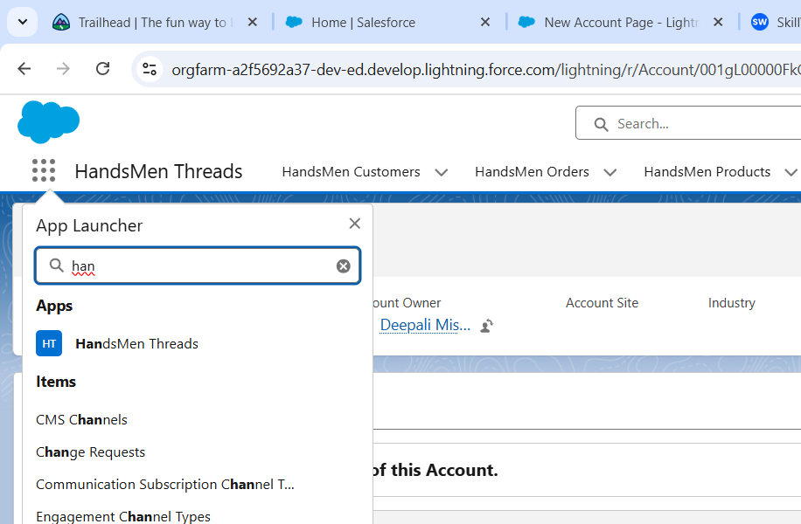

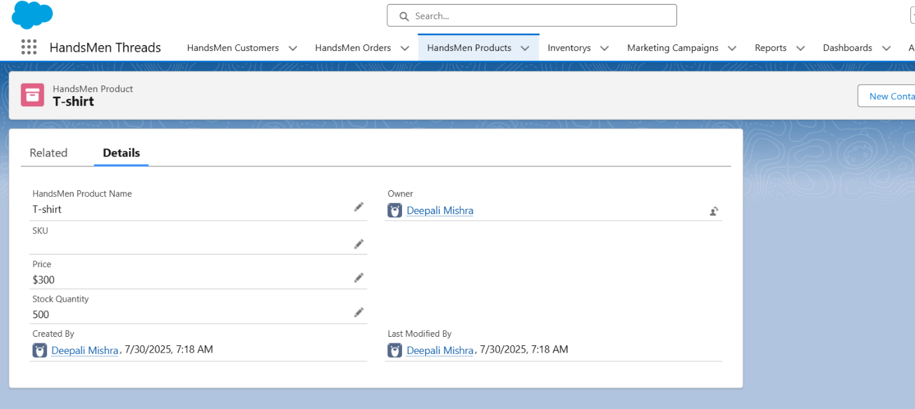

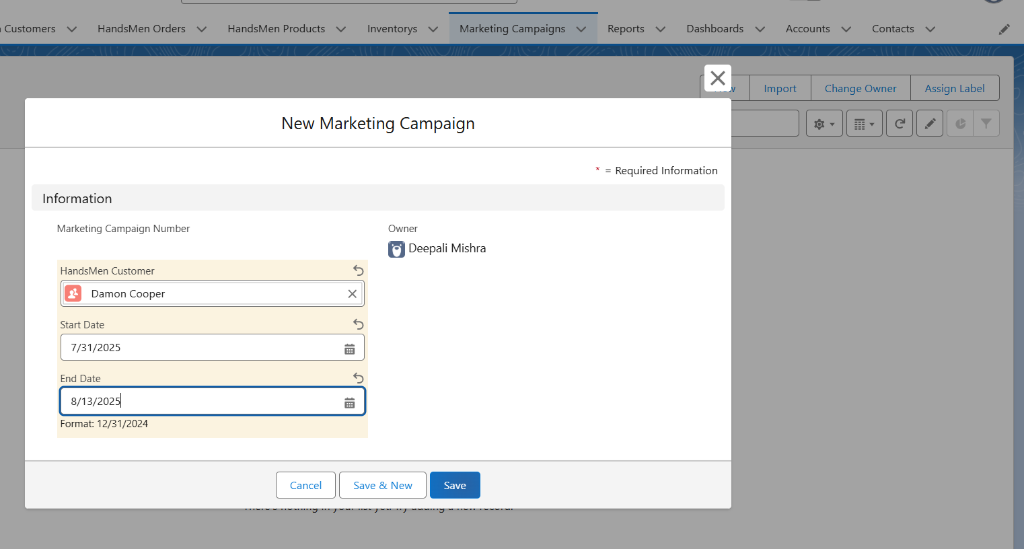
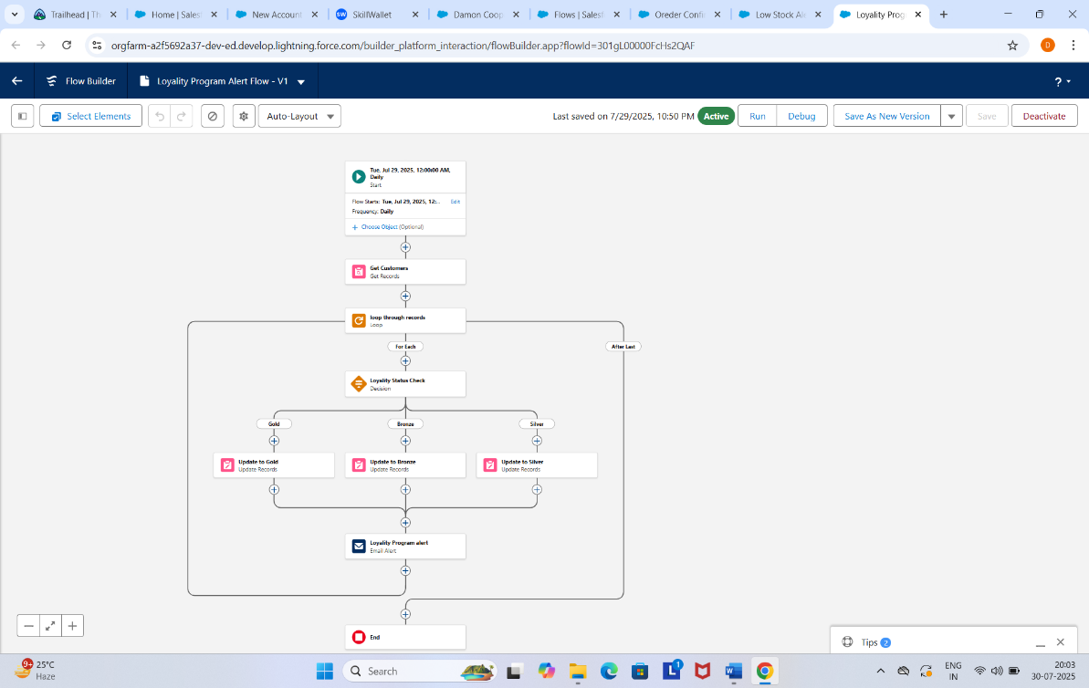

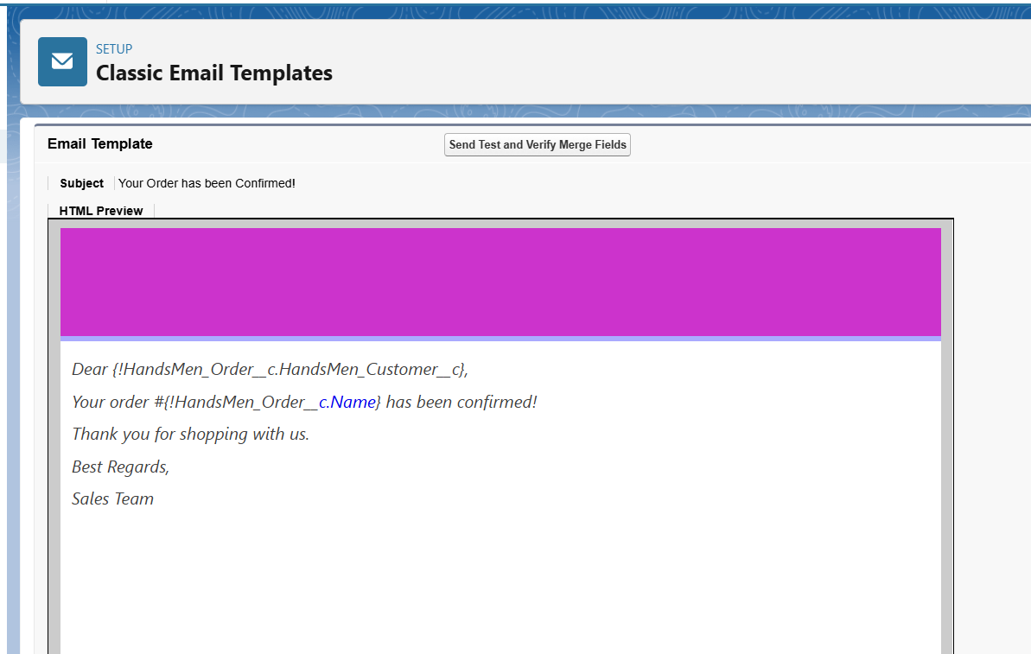

Conclusion
HandsMen Threads, a premium men's fashion brand, aims to leverage Salesforce to streamline operations, enhance customer experience, and optimize inventory management. This project focuses on implementing Salesforce CRM to manage customer orders, track inventory, automate marketing campaigns, and provide seamless customer service.
The project involves building a robust data model tailored to store all pertinent business data, ensuring a seamless flow of information across the organization.
A key aspect of this project is the maintenance of data integrity directly from the user interface (UI). This feature will safeguard the accuracy and consistency of the data, which is crucial for informed decision-making and reliable business operations.The project will integrate several new processes into the business workflow to improve customer service and operational efficiency

